Project Design Phase Proposed Solution

Date | 27 June 2025
M ID | 8050612605B5D909A0D43F9BC95E1D9A
Project Name | Garage Management system
Maximum Marks | 2 Marks

Proposed Solution Template:

S.No. | Parameter | Description
1. | Problem Statement (Problem to be solved) | In ServiceNow, users assigned to incidents can still be deleted. This leads to broken incident references, loss of accountability, and disruption of workflows.
2. | Idea / Solution description | A business rule is implemented on the sys_user table. It checks whether the user is currently assigned to any active incidents. If so, deletion is blocked with an error message.
3. | Novelty / Uniqueness | It addresses a critical real-world ITSM issue in a simple and effective way using native ServiceNow logic (no external plugins needed).
4. | Social Impact / Customer Satisfaction | It ensures better accountability and reliability for IT support teams, avoiding mistakes that lead to process breakdowns.
5. | Business Model (Revenue Model) | Not applicable directly, but can save time, reduce data corruption, and avoid miscommunication — leading to cost-effective ITSM operations for companies.
6. | Scalability of the Solution | The solution can be extended to include other modules like Change Requests or Problem Tickets. It can also be adapted for role-based restrictions in large teams.

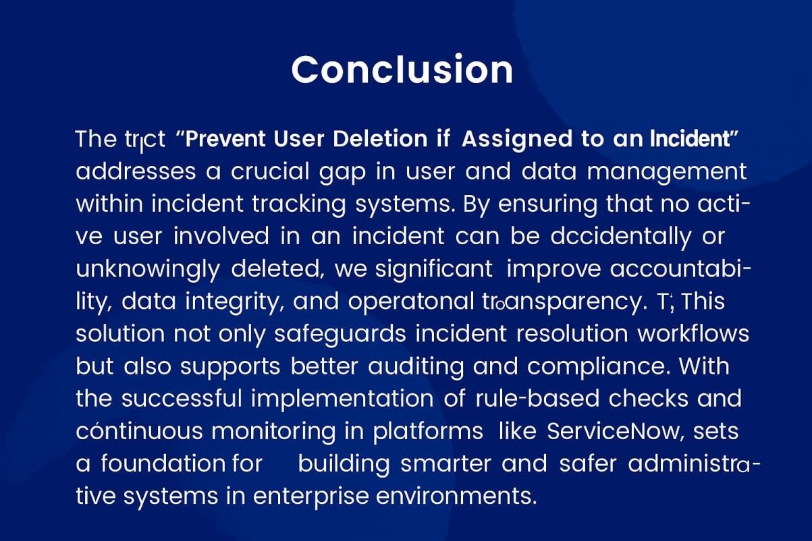
Reference: Infographic created using MidJourney.
Solution Description:
To prevent accidental deletion of users assigned to active incidents in ServiceNow, a custom business rule is implemented on the sys_user table. This rule checks whether the user is currently associated with any open incidents. If the system finds an active incident linked to the user, it blocks the deletion process and displays an appropriate error message. This approach leverages native ServiceNow functionality, making it simple, plugin-free, and easily adaptable. The solution enhances data integrity, ensures accountability in ITSM operations, and helps avoid breakdowns in incident resolution workflows.

